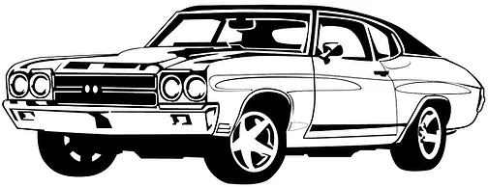
302 Bois D' Arc
Rockport TX 78382
November 4, 2023

$15 Registration fee is due at sign in.

Name ______________________________________________________________

Address ____________________________________________________________

Contact # ___________________________________________________________

Email Address _______________________________________________________

Categories:
Rat Rod _____
Street Rod _____
American Muscle _____
Late Model _____
Restoration _____
Truck _____

Street Rod – A heavily modified vehicle that was manufactured prior to 1948, or has been assembled or completely reconstructed resembling a vehicle manufactured prior to 1948, using new or used parts.
Restoration – A vehicle that has been returned to a mostly original condition based on how the car was originally designed and used. A vehicle made before 1990.
American Muscle – A car made originally in the United States and is generally identified by its original manufacturer but may be modified from the original model, such as engine and suspension modifications as well as tires and wheels. A vehicle generally manufactured after the late 1950s.
Rat Rod – A vehicle generally resembling what is considered a hot rod but appears to be in an unfinished but drivable state. Many rat rods are a combination of mismatched parts that may appear to come from many different manufacturers.
Truck – Any truck or vehicle identified as a truck which may have a bed whether covered or not. Vehicle can be modified in any way and be in this category as long as its purpose is that of a truck or a vehicle that might perform the duties of a truck. Various 2 and 4 wheel drive vehicles or vehicles based on a truck chassis may be in this category as well. Such as Jeeps, SUVs or possibly vans.
Late Model – Any car that is stock or mostly original and within 3 generations of the current model.

